NON-NUCLEAR PROLIFERATION
The 21st century is characterized by a complex international scenario that makes it difficult to forecast its repercussions in the medium and long term. Globalization and asymmetric threats contribute to diversify adversaries and motives that could lead to inexorable conflicts in global security.
https://nct-magazine.com/nct-magazine-october-2020/a-21st-century-perspective-on-nuclear-proliferation-and-nuclear-terrorism/

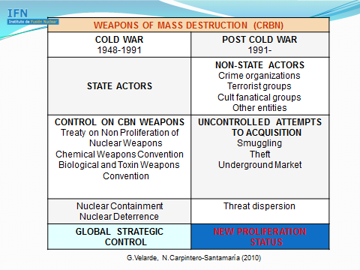
Nuclear and Radiological Terrorism
Nuclear terrorism is an evil application of nuclear energy. It could be perpetrated using any of the following means: 1) by crude or improvised nuclear devices (INDs); 2) by radiological dispersion devices (RDDs), also known as dirty or radioactive bombs; or 3) by attack on nuclear facilities (ANF).
Improvised Nuclear Devices (INDs) are atomic bombs that due to a deficient design, or the materials used or/and a poor-quality control of their components, they produce when exploding a yield lower than 1 kiloton of energy. The INDs can be made of uranium or plutonium but the project, the components, the quality control and their functioning are radically different. The uranium bombs would be the most suitable potential bombs for terrorism because they can be designed and made under a low-medium-technology profile. In this type of bombs, only from 1% to 5% of the WGU undergoes fission. However, the probability to reach the nominal yield is big. They can also be disassembled, and their components be easily transported by means of clandestine entrances in a country (private airports and ports, etc). The problem for the fabrication of these bombs lies in the acquisition of the WGU. It is unlikely that terrorist groups today could develop and manage the substantial infrastructure that would be required to produce enriched uranium or plutonium for weapons. However, nuclear weapons and weapon materials could be stolen by terrorists either from storage or during transportation.

https://nct-magazine.com/nct-magazine-march-2019/radiological-terrorism/

ILLEGAL TRAFFICKING OF RN MATERIALS/AGENTS
Covert acquisition of dual-use materials, both tangible and intangible, through illicit trafficking is produced by applying a series of techniques and strategies that are becoming increasingly sophisticated.
Combating illicit trafficking of RN materials is an arduous task due to the opacity of these camouflaged operations; indirect transmission; diversification of suppliers, etc.
The development of new technologies for transport and communication of goods via cyberspace, not only substantially facilitates the flow of RN illegal trade, but also enhances security for traffickers.
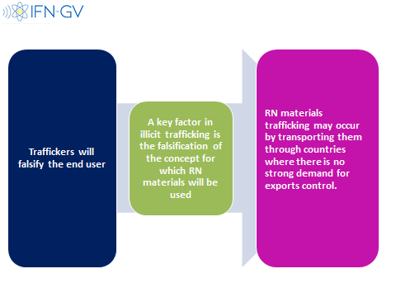

ITDB helps IAEA in improving Nuclear Security Plan.
Authoritative information from member countries (139 as Dec. 2019).
- GROUP I: Trafficking or malicious use.
- GROUP II: Undetermined intent
- GROUP III: Not connected with malicious use

